**Growth Hacking Marketing Strategy for Startups**

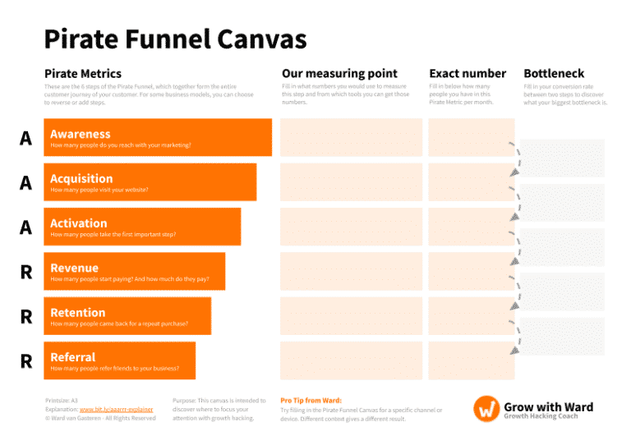

**Introduction to Growth Hacking**

Growth hacking is a marketing strategy focused on rapid experimentation across various channels and product development paths to identify the most effective ways to grow a business. It combines marketing, data analysis, and product management to achieve exponential growth in a short time. Unlike traditional marketing, growth hacking is more agile, resourceful, and driven by data.

**Key Components of Growth Hacking:**

1. **Creative Marketing**: Using innovative and low-cost strategies to increase brand awareness and user acquisition.
2. **Data Analytics**: Leveraging data to understand customer behavior, optimize campaigns, and make informed decisions.
3. **Product Engineering**: Implementing growth-focused features directly into the product to drive user engagement and retention.

**Steps to Develop a Growth Hacking Strategy:**

1. **Define Clear Goals**:
   * Identify specific, measurable, and time-bound goals. For example, "Increase the user base by 20% in the next three months" or "Double the revenue in Q4."
2. **Understand Your Target Audience**:
   * Deeply analyze your customer segments to understand their needs, pain points, and behavior. This understanding will guide your growth tactics.
3. **Optimize the Marketing Funnel**:
   * Break down the customer journey into the marketing funnel stages: Awareness, Acquisition, Activation, Revenue, Retention, and Referral. Analyze each step to identify bottlenecks.
4. **Experiment and Iterate**:
   * Develop hypotheses and run experiments to test different growth tactics. This could include A/B testing, content marketing, or referral programs.
5. **Measure and Analyze**:
   * Use data analytics to measure the impact of your experiments on each stage of the funnel. Tools like Google Analytics, or custom templates shared below can help track metrics.
6. **Scale What Works**:
   * Once you identify successful strategies, focus on scaling them while continuing to experiment with new ideas.

**Activity Template**

|  |  |  |  |  |  |
| --- | --- | --- | --- | --- | --- |
| No. | **Marketing Funnel Canvas**  **Metrics:** the steps that will define the entire journey of your customer. | **Measuring point:** numbers used to measure each step and from which tools you can get those numbers. | **Exact Number:** the number of people in each metric per month | **Bottle Neck:** fill in the conversion rate between two consecutive steps to discover what your biggest bottleneck is. | **Remark**: possible ways you can increase the conversion rate or break the bottle neck at each step. |
| 1 | *Awareness:* how many people do you reach with your marketing? |  |  |  |  |
| 2 | *Acquisition:* how many people visit your website, social media pages? |  |  |  |  |
| 3 | *Activation:* how many people take the first important step? How many people visit your website, store, or contact you? |  |  |  |  |
| 4 | *Revenue:* how many people start paying? And how much do they pay? |  |  |  |  |
| 5 | *Retention:* how many people come back for a repeat purchase? |  |  |  |  |
| 6 | *Referral:* how many people refer friends to your business? |  |  |  |  |